Document of ViewResolver Configuration in Spring
Date: 2017-03-23
Prepared By : Garun Kumar Mishra

This document contains the following points:
i. ViewResolver.
ii. HandlerMapping
iii. Exact difference and working of DAO and Service layer.
Flow of SpringMVC :

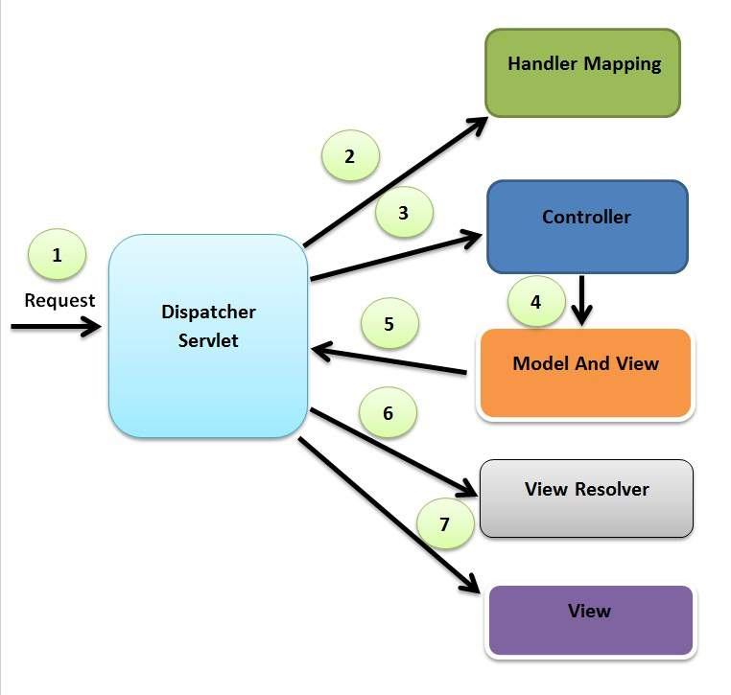

i. ViewResolver :

1. Overview of ViewResolver :
=> In the MVC Architecture of Spring after getting responce of ModelAndView, The frontend Controller(DispatcherServlet) send the responce to ViewResolver to get the appropriate /exact view of request which is totally depend on request and response. On the behalf of returned response from Viewresolver, DispatcherServlet generates the view page.

=> The ViewResolver maps view name to actual view.
=> Springframework comes with quite a few ViewResolver as given below :
a. InternalResourceViewResolver : InternalViewResolver allow us to set properties such as prefix, suffix to the view name to generate the final view page url. After configuration we only need of jsp page to keep in /WEB- INF/view/ folder.
@Bean
public ViewResolver internalResourceViewResolver(){
InternaResourceViewResolver bean = new InternalResourceViewResolver();
bean.setViewClass(JstlView.class);
bean.setPrefix(“/WEB-INF/view/”);
bean.setSuffix(“.jsp”);
return bean;
}

b. ResourceBundleVewResolver: As the name of this resolver suggest a ResourceBundleViewResolver uses bean definition in ResourceBundle. This bundle is typically defined in a properties file located in classpath. Example is given as below:
sample.(class)=org.springframework.web.servlet.view.JstlView
sample.url=/WEB-INF/view/sample.jsp
@Bean
public ViewResolver resourceBundleViewResolver(){
ResourceBundleViewResolver bean = new ResourceBundleViewResolver();
bean.setBaseName(“views);
return bean;
}

c. XmlViewResolver. This implementation of ViewResolver accept a configuration file written in XML with the same Document Type Definition(DTD) as Spring XML bean's factories.
@Bean
public ViewResolver xmlViewResolver(){
XmlViewResolver bean = new XmlViewResolver();
bean.setLocation(new ClassPathResource(“views.xml”));
return bean;
}

The configuration file views.xml is given below:
<beans xmlns="http://www.springframework.org/schema/beans" xmlns:xsi="http://www.w3.org/2001/XMLSchema-instance" xsi:schemaLocation="http://www.springframework.org/schema/beans http://www.springframework.org/schema/beans/spring-beans-4.2.xsd">
<bean id=”xmlConfig” class=”org.springframework.web.servlet.view.JstlView” > <property name=”url” value=”/WEB-INF/view/xmlSample.jsp” />
</bean>
</beans>

2. Configuration of VieResolver using java classe file.
@EnableWebMvc
@Configuration
@ComponentScan(“org.com.ebs”) // this scan the base package.
Public class WebConfig extends WebMvcConfigureAdapter{

// Add an InternalResourceViewResolver

@Bean
public ViewResolver internalResourceViewResolver(){
InternaResourceViewResolver bean = new InternalResourceViewResolver();
bean.setViewClass(JstlView.class);
bean.setPrefix(“/WEB-INF/view/”);
bean.setSuffix(“.jsp”);
return bean; }

//Add a ResourceBundleViewResolver

@Bean
public ViewResolver resourceBundleViewResolver(){
ResourceBundleViewResolver bean = new ResourceBundleViewResolver();
bean.setBaseName(“views);
return bean; }

//Add an XMLViewResolver

@Bean
public ViewResolver xmlViewResolver(){
XmlViewResolver bean = new XmlViewResolver();
bean.setLocation(new ClassPathResource(“views.xml”));
return bean; }
}

ii. HandlerMapping :

1. Overview of HandlerMapping:
=> Handlermappiing is an interface that is implemented by all objects that map the request to corrosponding Handler Object. The HandlerExecutionChain always wrap the Handler and may also contains one or more HandlerInterceptor.
=> The default implementations used by the DispatcherServlets are BeanNameUrlHandlerMapping and DefaultAnnotationHandlerMapping.
=> BeanNameUrlHandlerMapping: this maps a URL to bean name. For example the url “/app” would map to Handler named “/app”. This also support “*” wildCard mapping, so “/a*” matches both “/app”, “/apple” etc. The class does and ant style matching so “/app/*” matches all path in the apps directory, and “/app/**” matches all path below app.
=>DefaultAnnotationHandlerMapping: Mapping decleared via the @Requestmapping annotation are mapped via this handler. The annotation may be expressed at the merhod level or type level. This mapping is registered by default, However you register a custom Handler then default Handler is overriden. @RequestMapping is may be defined as type level and method level.
=> apart of these, some of other Handlermapping is given as follows:
a. ControllerBeanNameHandlerMapping
b. SimpleUrlHandlerMapping
c.ResquestMappingHandlerMapping
@RequestMapping(value = "/app", method = RequestMethod.GET)
public void findPet(@MatrixVariable int a,@MatrixVariable int b) {
// a == 10
// b == 11
}
Important :
=> When a request comes to Spring's DispatcherServlet, It hands over that request to handler mapping.
=>Handlermapping then inspect the request and identifies the appropriate handler execution chain and deliver it to dispatcher servlet.
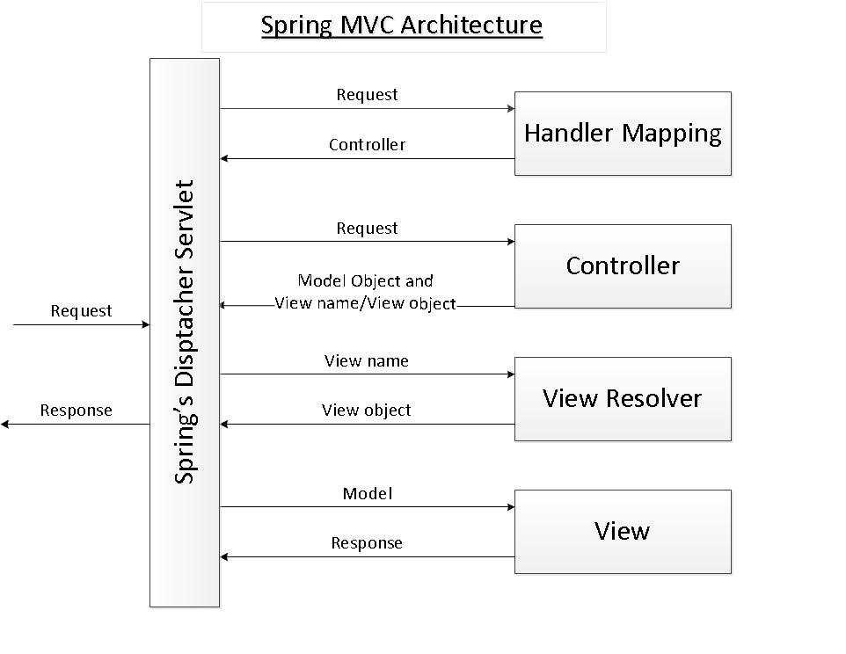

iii. Data Access Object(DAO) and Service Layer in MVC:

a. Data Access Object Layer in MVC:

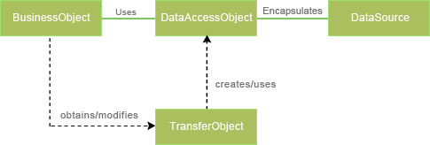

=>Data Access layer has proven good in seperate Business Logic layer and persistent layer.
=> The DAO design pattern completely hides the data access implementation from its clients. The interfaces given to the client doesnt changes when the underlaying data source mechanism changes.
=>This is the capability which allows the DAO to adopt different access scheme without effecting to business logic or it clients.
=>generally it acts as an adopter between its components and database.
=> The Dao design pattern consist of some factory classess and some dao classes to implements those interfaces.
Structure of DAO:
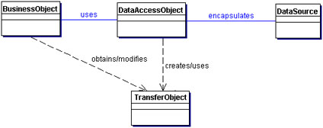

Participant and Responsibilities:
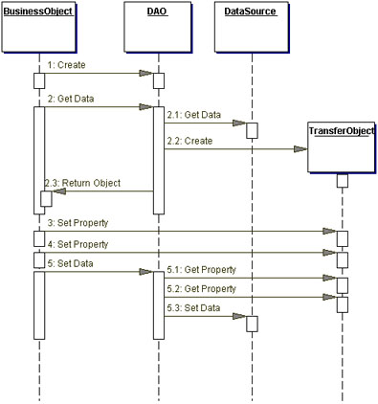

BusinessObject
The BusinessObject represents the data client. It is the object that requires access to the data source to obtain and store data. A BusinessObject may be implemented as a session bean, entity bean, or some other Java object, in addition to a servlet or helper bean that accesses the data source.

DataAccessObject
The DataAccessObject is the primary object of this pattern. The DataAccessObject abstracts the underlying data access implementation for the BusinessObject to enable transparent access to the data source. The BusinessObject also delegates data load and store operations to the DataAccessObject.

DataSource
This represents a data source implementation. A data source could be a database such as an RDBMS, OODBMS, XML repository, flat file system, and so forth. A data source can also be another system (legacy/mainframe), service (B2B service or credit card bureau), or some kind of repository (LDAP).

TransferObject
This represents a Transfer Object used as a data carrier. The DataAccessObject may use a Transfer Object to return data to the client. The DataAccessObject may also receive the data from the client in a Transfer Object to update the data in the data source.

b. Service Layer:
=>It is considered a good practice to use modularity across Spring Web Application. It keeps them maintainable and testable. This can be achiev by controller, service and dao.
=>Typically a user request is handled by controller, which calls a service, and the service calls data access objetc(dao) and dao calls persistence layer implementation.
=>Using service means application functionalities can be tested without a test framework simulating user calls to controller.
=>Seperating service from the persistence layer impllementation viw DAO, allow using an in-memory database(for example) by substituting production DAO implementations, by tested DAO implementation pointing to an in-memory database.
=> in-memory database, means spring configuration allow to configure multiple database(like HSQLDB, MySQLDB, Oracle, H2, etc). Service layer is benifificial in this situations.
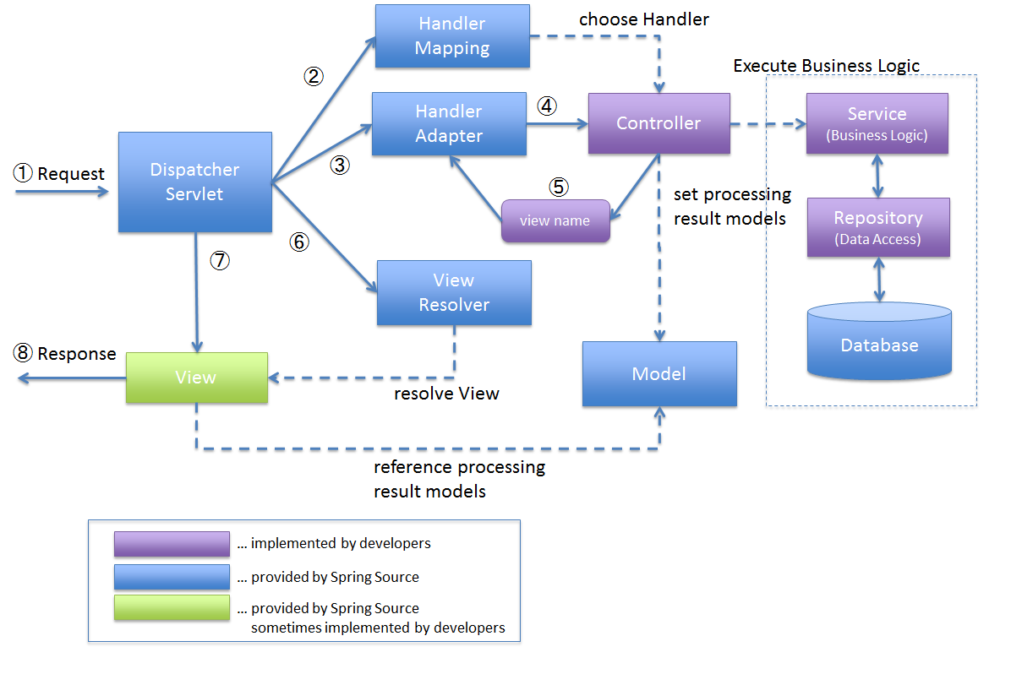
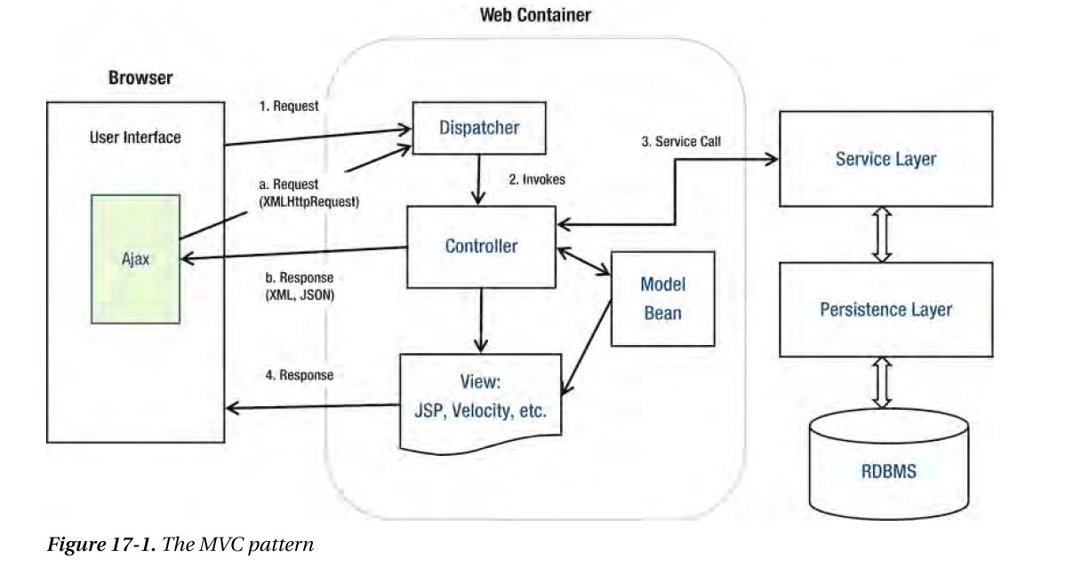

Some Important Fact in annotation of Spring:
1. @Transcational annotation at the top of the class. That basically means, that DAO methods will run within transcations. To make it work, we need to alter our persistence-beans.xml file and declare there transaction manager, which will be handling the transactions. Just add following lines (new bean definition):

<bean id='transactionManager' class='org.springframework.orm.hibernate3.HibernateTransactionManager' >
<property name='sessionFactory' ref='sessionFactory' />
</bean>

2. @Autowired, we are autowiring sessionFactory using setter injection. Field injections looks best with Spring because annotation resides directly at fields, not on constructor or setter fileds.

3. Every DAO file contains @Repository annotation, because we won't create them by hand but have them inject and managed by Spring's Ioc Container.

Some other annotations are given below:
@Component – autoscan component (Spring bean)
- @Repository – component in persistence layer (usually DAO)
- @Service – component in service layer
- @Controller – controller in MVC architecture
: Garun Kumar Mishra

